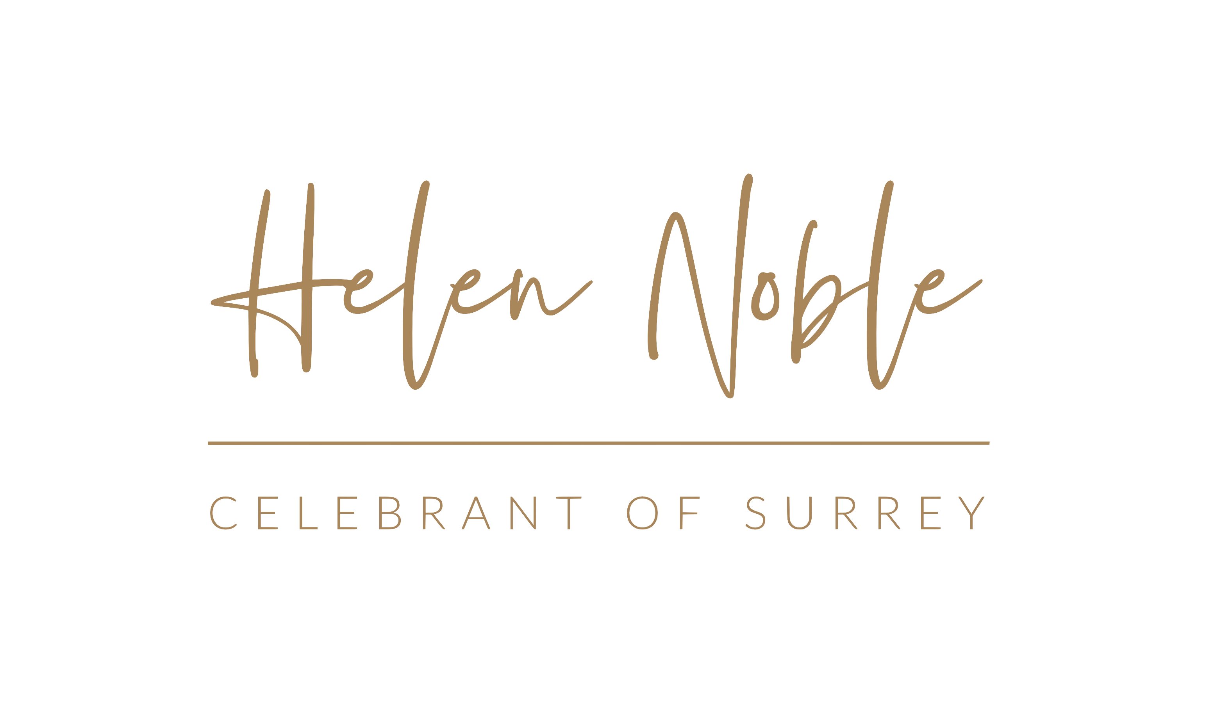

It’s the gift that keeps on giving – that’s one way that you could look at wedding planning! My couples are still positive with their wedding planning. Having a Celebrant led wedding means the focus is the ceremony. The ceremony is the one constant. In this changing world, the constant is the love between the couple and their drive to get married. The proposal may have been months in the planning. The ring may have been designed and made just for you. The parents may have been asked . All the hope for a happy life together is already in place. It’s all you need! As the Beatles sang ‘all you need is love’ THIS is where you find your security. THIS is where you will find your anchor, your tether, your base line. It is in your marriage vows. It is in the hope of the love that will last a life time. Your marriage vows to each other – which you have responsibility for - is what everything centres around, not what the latest guidelines are.

I have 30 years of being part of ceremonies one way or another. I have 20 years of event experience and I have 200 celebrant led weddings under my belt that I have created written and delivered to couples. I can absolutely bring solutions to your wedding worries. A celebrant will give you the consistency you crave, the guidance you want and the creativity to be the spring board to the vision of your marriage as well as your wedding day!

www.helen-noble.co.uk

